**PetBook Capstone Project**

# Introduction

The pet service industry is a diverse and growing market (worth $261 billion globally) that provides a wide range of services and products to meet the needs of pet owners and their pets. The overarching trend in pet care is the accelerated humanisation of family pets, which will continue to grow strongly over the forecast period. The pandemic has meant that the appreciation of pets has reached an all-time high in New Zealand and led to growing recognition among owners that their pets should be treated like a member of the family.

PetBook is a platform that allows users to register, login with the purpose of digitalising and storing their pet's information in one handy space.

## Purpose

* **What is the problem or the opportunity that the project is investigating?**

In today's digital age, most pet owners are already using smart devices, so it’s not surprising that they would turn to technology to stay more connected with their pets throughout the day. However, it is still commonplace for pet information to be stored in more traditional forms e.g., vet pet book which can be inefficient, risky, and costly.

This project looks at addressing this problem by providing opportunities to enhance pet health, communication, efficiency, personalization, and convenience.

* **Why is this problem valuable to address?**

Digital storage offers many advantages over paper storage, including increased accessibility, security, and sustainability.

1. **Space efficiency**: Digital storage requires significantly less physical space than paper storage. Instead of needing a physical filing cabinet or storage room, digital information can be stored on a computer or server.
2. **Accessibility:** Digital information can be accessed from anywhere with an internet connection, making it easy to share and collaborate with others. This is particularly useful in the age of remote work and distributed teams.
3. **Searchability:** Digital information can be easily searched and indexed, making it faster and easier to find specific information. This is particularly useful when dealing with large amounts of data.
4. **Durability:** Digital information can be stored and backed up in multiple locations, reducing the risk of loss or damage. This is particularly useful for important or sensitive information.
5. **Sustainability**: Digital storage is more environmentally friendly than paper storage, as it reduces the need for paper production and transportation.

* **What is the current state (e.g. unsatisfied users, lost revenue)?**

The digital pet information storage and management industry is a niche market within the broader pet care industry but is expected to continue growing as more pet owners become aware of the benefits of using digital tools to manage their pets' care

* **What is the desired state?**

To create a platform that provides services to pet owners to organise and manage their pet's health etc stress-free. Users control their data and can decide on how it's used and shared.

* **Has this problem been addressed by other projects? What were the outcomes?**

Digital pet data storage domain is still relatively small compared to other segments of the pet care industry but yes. These projects have proved quite popular with their users although not well known in NZ

## Industry/ domain

* **What is the industry/ domain?**

Pet services Industry

* **What is the current state of this industry? (e.g. challenges from startups)**

The pet service industry is currently thriving, with the demand for pet services and products increasing steadily in recent years. This has resulted in a surge in demand for pet-related services, such as veterinary care, grooming, boarding, pet sitting, and dog walking. However, the pet service industry is not without its challenges. One of the biggest challenges is building a brand and reputation in a crowded and competitive market. Many startups also struggle with funding and scaling their operations, particularly when it comes to expanding into new markets or regions.

* **What is the overall industry value-chain?**

The pet service industry makes money in various ways from getting consumers to register for a pet service platform to ads on their apps or websites, to paid premium services and subscriptions.

* **What are the key concepts in the industry?**

Common focus on health and wellness of a pet beyond high-quality food where owners are spending more on items and conveniences that focus on theirs pets health in a holistic or pampering way.

* Get as many users and subscribers as possible to the service.
* The more users, the more ads and promotions.
* The more ads and promotions, the more exposure and profit.
* Staying ahead of trends to prevent losing market share.
* **Is the project relevant to other industries?**

Yes, many of the features and benefits of a digital pet information storage app, such as easy access to information, improved accuracy, and enhanced security, can be applied to other industries where information management is crucial healthcare, finance, retail, and education

## Stakeholders

* **Who are the stakeholders? (be as specific as possible as to who would have access to the software)**

Anyone who owns a pet

* **Why do they care about this software?**

Digitalising pet information can help users provide better care for their pets. By using an app to stay organized, pet owners can feel more confident and less stressed, which can benefit both the pet and the owner. Increased security, convenience and sustainability are other benefits.

* **What are the stakeholders’ expectations?**

They expect PetBook to be easy to use, useful, affordable and accessible

# **Product Description**

Architecture Diagram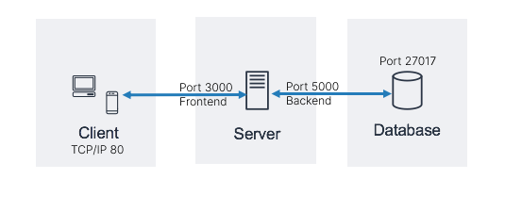

## **User Stories**

|  |  |  |  |  |
| --- | --- | --- | --- | --- |
| # | User Story Title | User Story Description | Priority | Additional Notes |
| 1 | Availability | As an end user, I want the same content and services to be accessible across multiple devices | 1 |  |
| 2 | Interface | As an end user, I want the interface to be intuitive and responsive as well as have a similar feel across multiple devices | 2 |  |
| 3 | Content | As an end user, I want the ability to be able to upload, update records and pet information as needed | 1 |  |
| 4 | Housekeeping | As and end user, I want to be able to edit information to keep everything updated or delete information that I no longer require | 2 |  |
| 5 | Locating Content | As an end user, I want an easy and reliable way to access relevant content in any place and time | 1 |  |
| 6 | Managing content | As end user, I want an easy way to manage, schedule and organize my pet (information) to ensure the best quality of life for them | 1 |  |

## **User Flow**

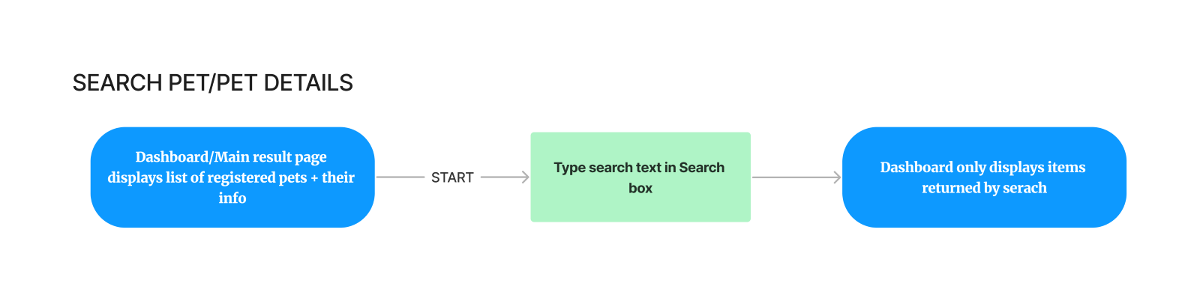  
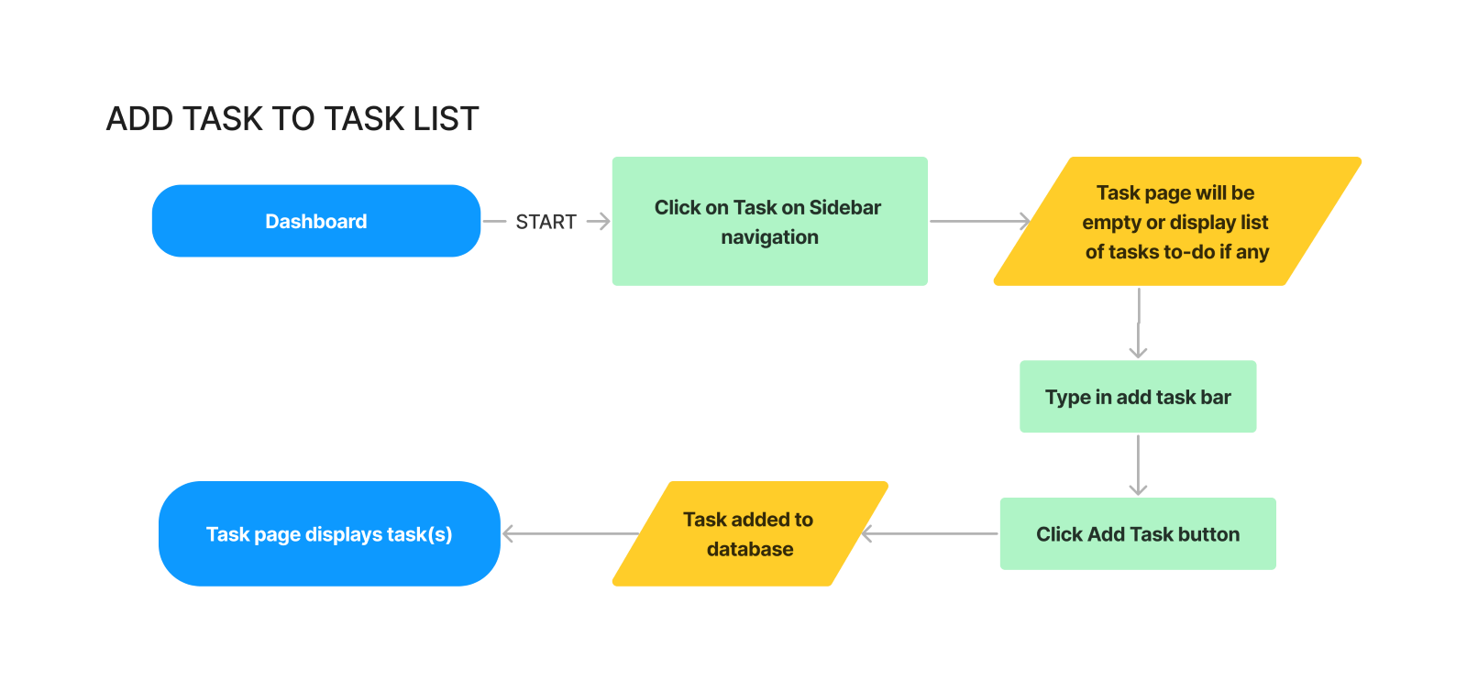

## Wireframe Design

## 

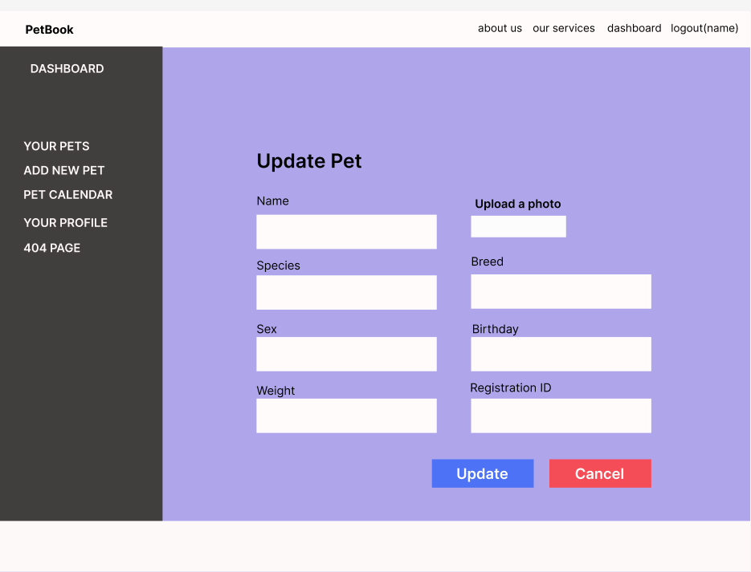

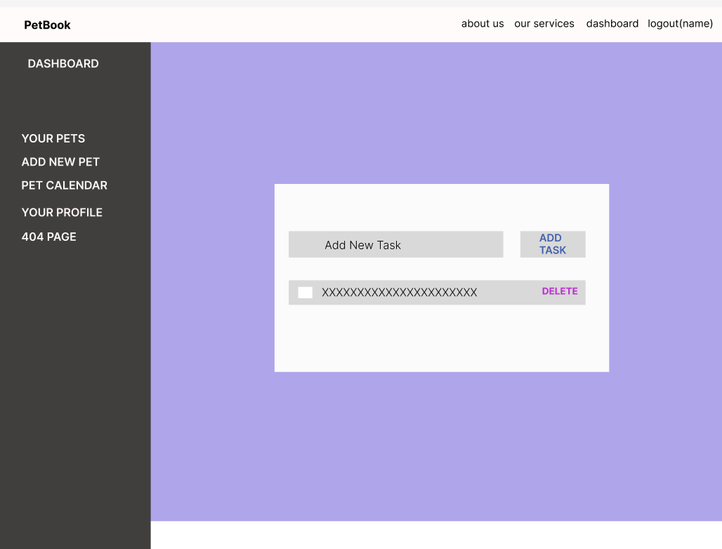

## **Open Questions/Out of Scope**

**In scope**

* Register new user
* Edit user details
* Retrieving all items
* Search by pet details/record details
* Register new pets
* Update existing pets
* Add pet health records
* Update pet records
* Delete records
* Private content
* Automatic database creation

**Open Questions/Out of Scope**

The following are considered out of scope:

* Encryption/HTTPS
* Multiple file uploads. Currently only able to upload single files of specified type (images)
* User customization currently limited
* Automated reminders and user notifications (could be in scope if I had more time)
* ‘Forgot password’ retrieval service
* Inclusion of an existing vet and pet care knowledge database

## **Non-functional Requirements**

* **What are the key security requirements? (e.g., login, storage of personal details, inactivity timeout, data encryption)**

Users register with a name, email and password. User details get stored in the database as plain text. Passwords are hashed before being saved so user accounts and data will not be compromised by any unauthorized access to the database

The database is hosted by Mongo Atlas and Mongo Compass.

The database name, password and username are stored in the backend and are added after the server is deployed and installed.

Any personal information added to the database is private and requires proper user-specific authentication and authorization to be accessed.

* **How many transactions should be enabled at peak time?**
* **How easy to use does the software need to be?**

Very easy or easy as people of various ages should be able to use this application.

* **How quickly should the application respond to user requests?**
* **How reliable must the application be? (e.g. mean time between failures)**

The application response time depend on the reliability of the user's connection.

* **Does the software conform to any technical standards to ease maintainability?**

The backend uses the Model View Controller (MVC) structure, and the frontend has hooks that implement functionality between components.

Grouping of similar elements e.g., profile items are also used to maintain structure and organisation

# Project Planning

Include a Gantt chart or screenshot of a Trello board showing key milestones (with dates) to complete the project.

[Trello Board](https://trello.com/invite/b/04OigNJg/ATTI5fcbe0ea3e90770768013e64e4873cc60BB006C1/capstone)

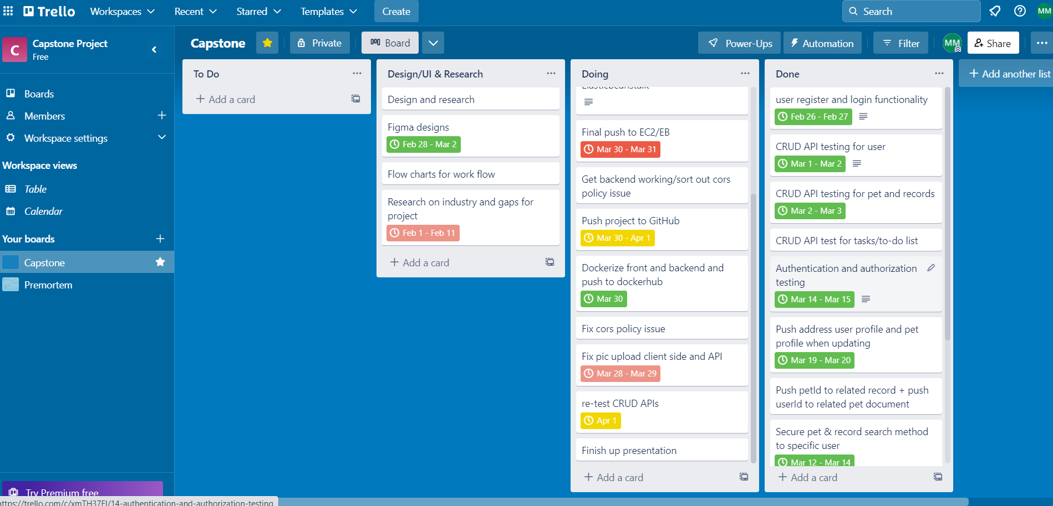

Visit [PetBook Figma](https://www.figma.com/file/l4WlDx7f4g0stzTOU4oMOE/PetBook?node-id=5%3A2&t=fjL6htSQhZVHHTLB-1) for an interactive user flow.

# Testing Strategy

* **What were steps undertaken to achieve product quality?**
* **How was each feature of the application tested?**

The quality of the product was achieved by ensuring continual testing and development. At each test, bugs were recorded. These then went back to the development stage to be fixed.

For easier identification and editing, code is cleanly written and consistent documentation of application and code was ensured

Client-side functionality was checked via following testing script:

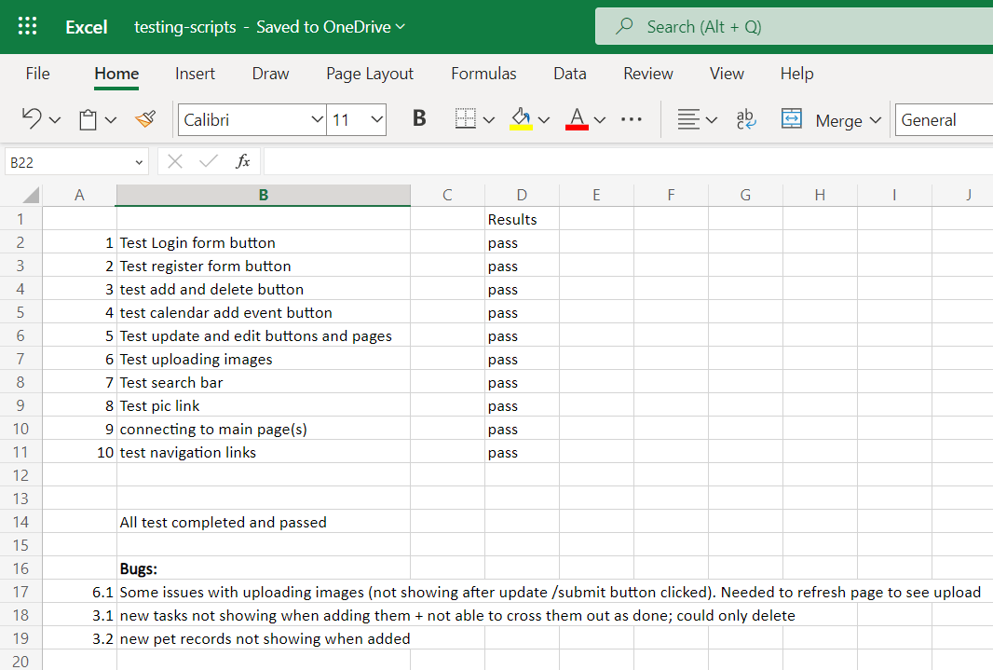

Postman was used to test during API creation.

* **How did you handle edge cases?**

console. logs’ were used extensively in every step to check for any abnormalities.

# Implementation

* **What were the considerations for deploying the software?**

Using AWS EC2 Or Elastic beanstalk with docker compose is considered for this project.

To allow 24x7 access for any device, the software would be deployed to AWS EC2/EB free tier. A user installing the same software has the option to choose their own hosting provider.

Each user needs to set up their own database to not incur costs and sharing of their links Database configuration needs to be added post install. Instructions form part of the Read Me.

# End-to-end solution

* **How well did the software meet its objectives?**

It went well. PetBook registers users and securely stores owner/pet information.

References

* **Where is the code used in the project? (link to GitHub)**

Code and documentation relating to this project is available from the following GitHub repository: <https://github.com/unishu/Capstone-Project-PetBook>

* **What are the resources used in the project? (libraries, APIs, databases, tools, etc)**

The following resources were used:

React

Expressjs

Mongo Compass

Docker

Nodemon

node

cors

body-parser

Cloudinary

Pexels

Database is hosted by <https://www.mongodb.com/atlas/database>

Frontend and backend are hosted on AWS EC2 and Elastic beanstalk.